Assesment Exercise for Getting started and Introduction of PHP 

1. Steps(with command and screenshots) for installing apache.

Answer 1:

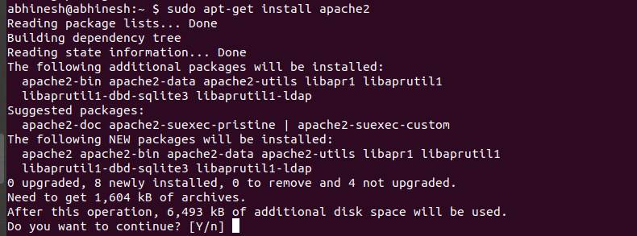

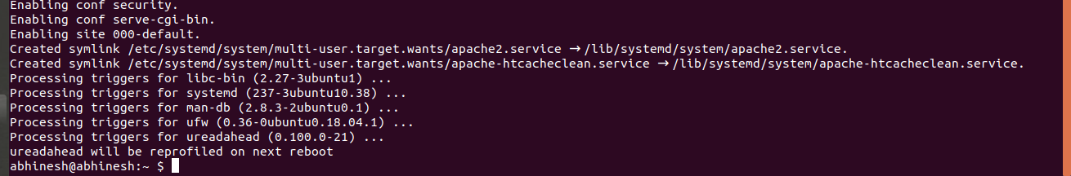

1. Installation steps(with command and screenshots) PHP and print current version

Answer 2:

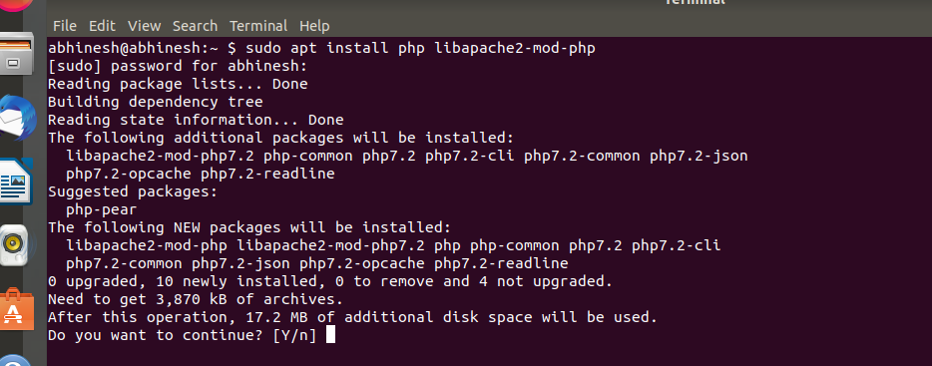

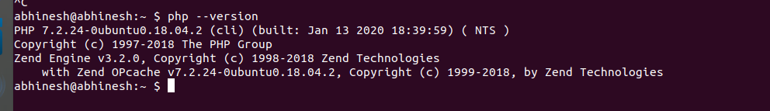

1. Installation steps(with command and screenshots) MySQL and print the current version

Answer 3: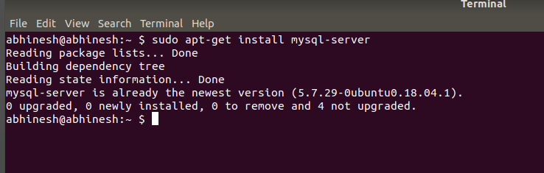

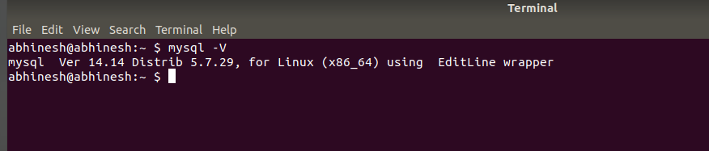

1. What is HTTP?

Answer 4:

Hyper Text Transfer Protocol is anapplication layer protocol for transmitting hypermedia documents, such as HTML. It was designed for communication between web browsers and web servers, but it can also be used for other purposes. HTTP follows a classicalclient-server model , with a client opening a connection to make a request, then waiting until it receives a response. HTTP is astateless protocol, meaning that the server does not keep any data (state) between two requests.

1. What domain name will have the following address – 127.0.0.1

Answer 5: 127.0. 0.1 is the loopback Internet protocol (IP) address also referred to as the localhost. The address is used to establish an IP connection to the same machine or computer being used by the end-user .

1. What language should you use for writing queries for the database?

Answer 6: While almost all programming languages can connect to and exchange information with an SQL database, PHP has a special relationship with this language—especially through the MySQLi DBMS (The "i" stands for "improved"). In fact, PHP and MySQLi work so well together on Linux Apache systems .

1. Which command is used for restart apache

Answer 7:

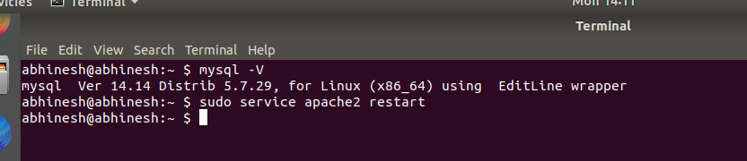

1. Print fibonacci series

Answer 8:

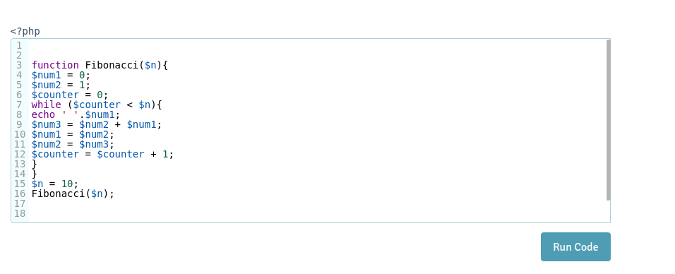

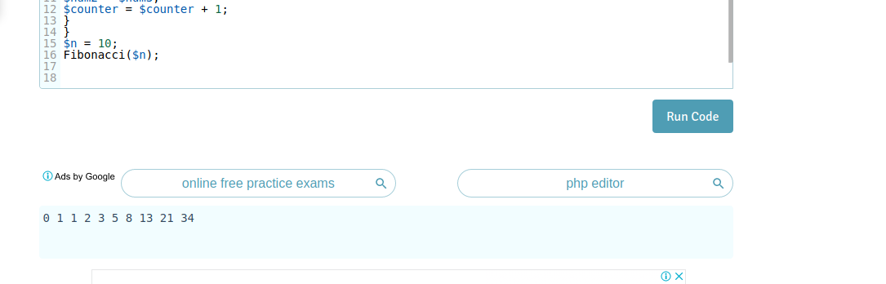

* Print 1 & 6 using **foreach** in array( 1, 2, 3, 4, 5, 6, 7 )

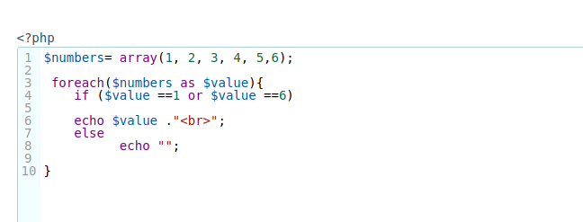

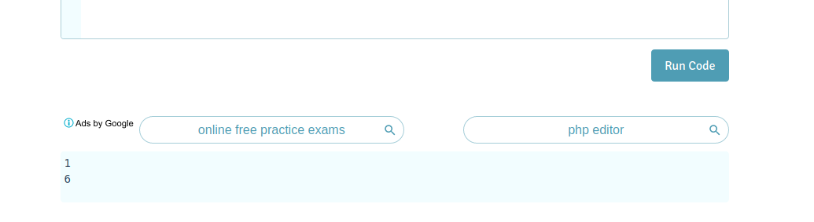

* Print 1 2 3 4 using **break** and **foreach** in array( 1, 2, 3, 4, 5, 6, 7 )

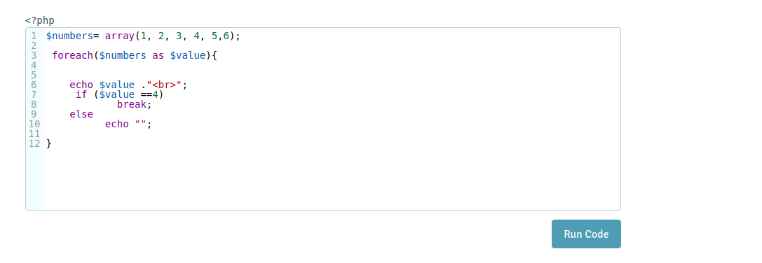

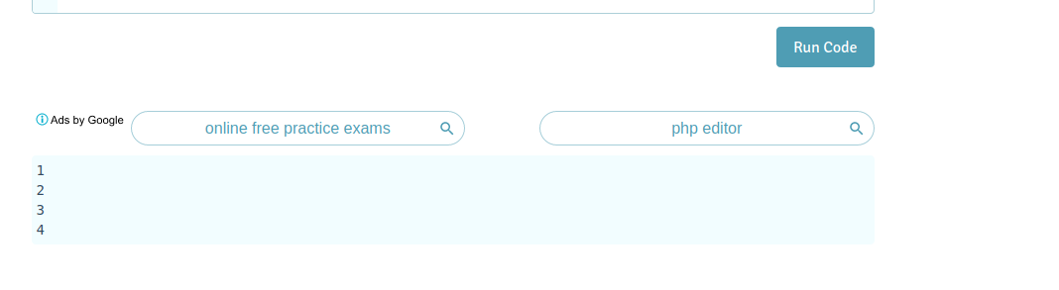

* Using **switch case**, check if value ($value = 4) is greater than 5 or not. Case should be 1, 2, 3, 4, 5, 6.

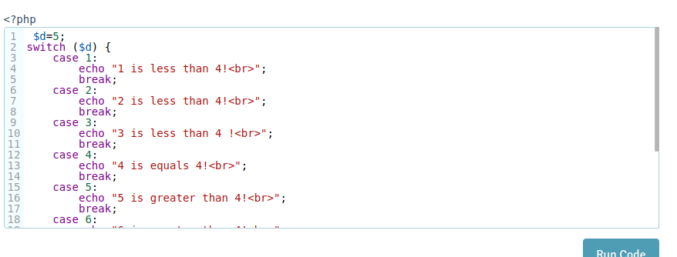

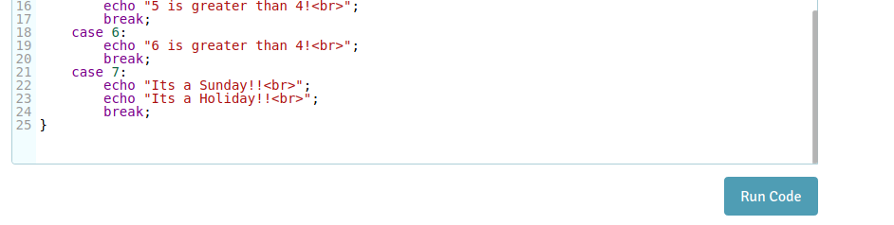



* Create and print an **infinite** loop.

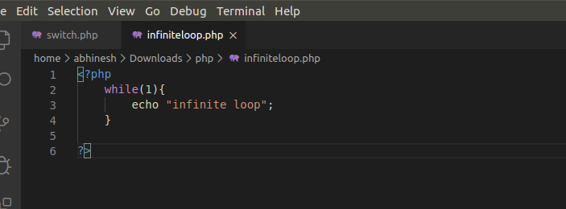

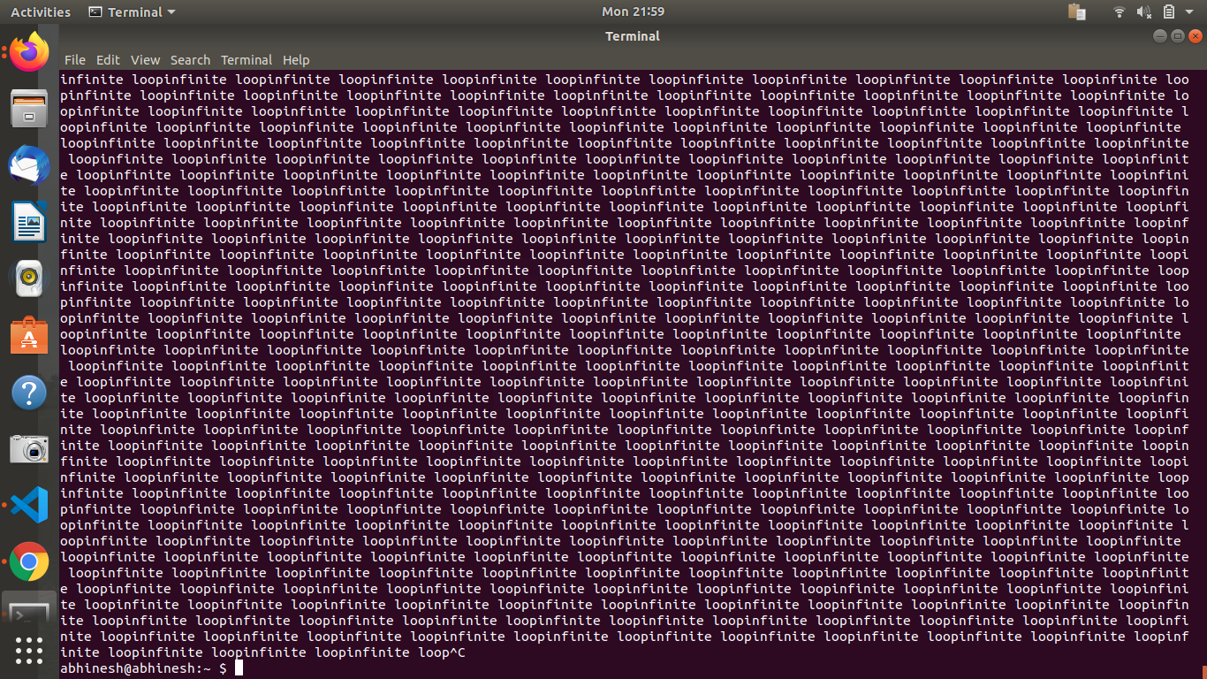

* Create a script that displays 1-2-3-4-5-6-7-8-9-10 on one line. There will be **no hyphen**(-) at the starting and ending position.

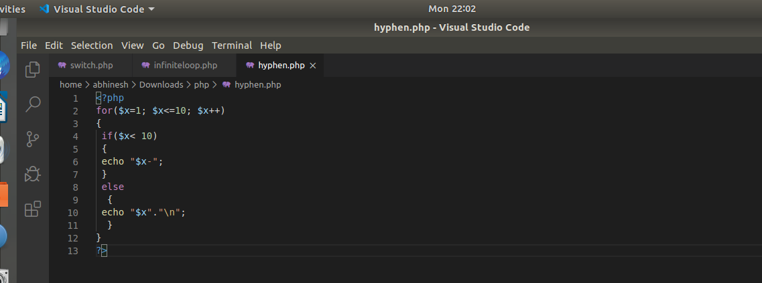

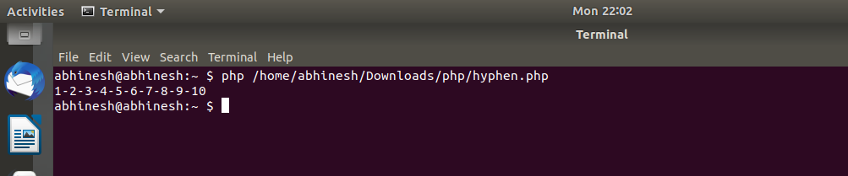

* Using **Alternative syntax** print values of array( 1, 2, 3, 4, 5, 6, 7 )

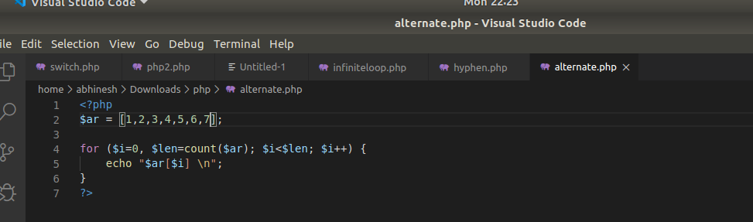

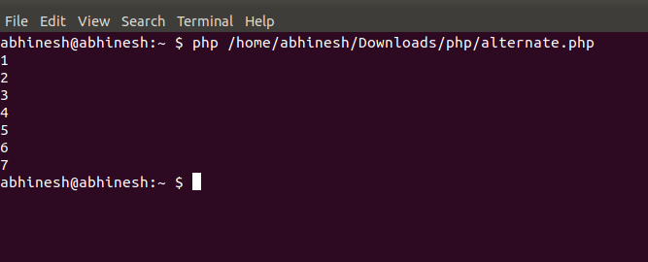

* Print 1,2,3,6,7 from array( 1, 2, 3, 4, 5, 6, 7 )

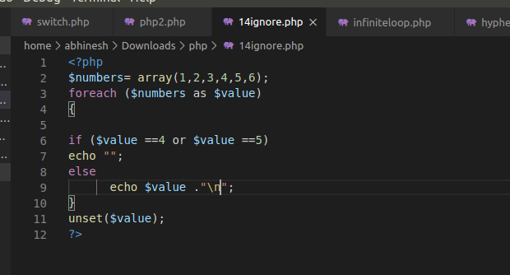

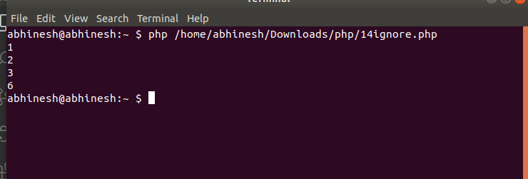

* Create a function to calculate **factorial value** of a number. Use this function to get factorial of 5.

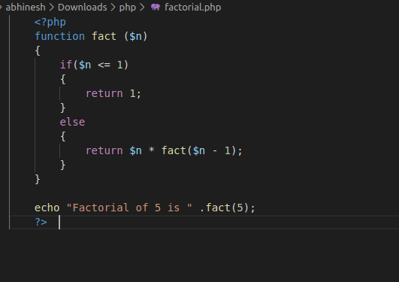

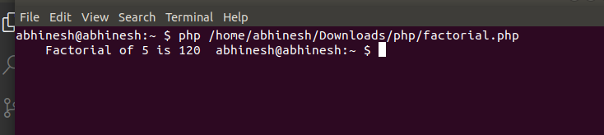

* Include a PHP file (abc.php) in another file (xyz.php) and use **variables** from abc.php in xyz.php

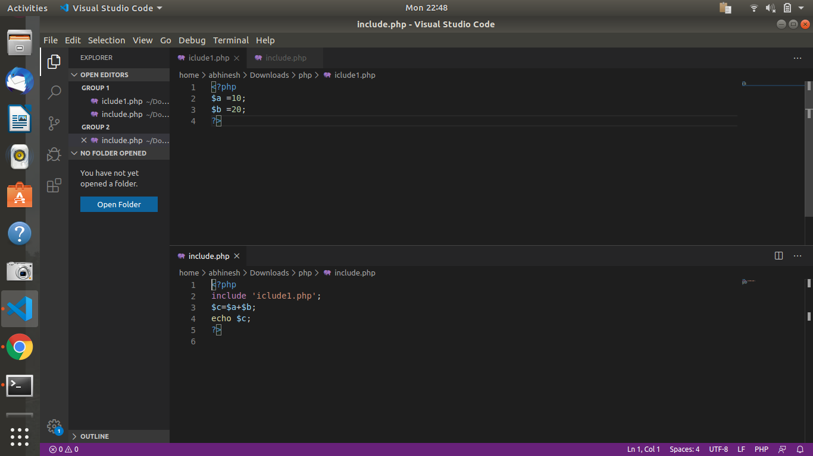

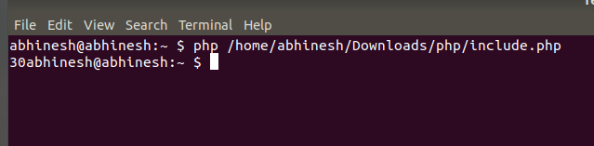

* Using loop find the **sum** of numbers from 1 to 15.

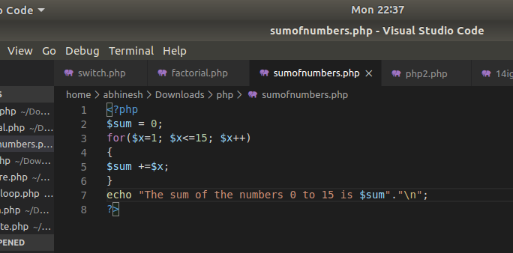

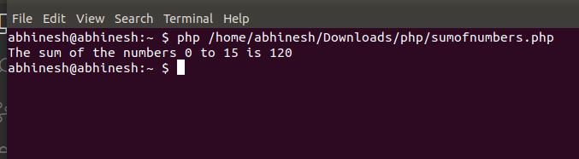

* Give examples of Print, printf, sprintf.

